Temogo Masuku
07/04/2025

CLDV6211 POE PART 1
ST10461592

Web app URL: https://st10461592.azurewebsites.net/
Github URL: https://github.com/ST10461592-Temogo-Masuku/Event-Ease
- Screenshot of ERD
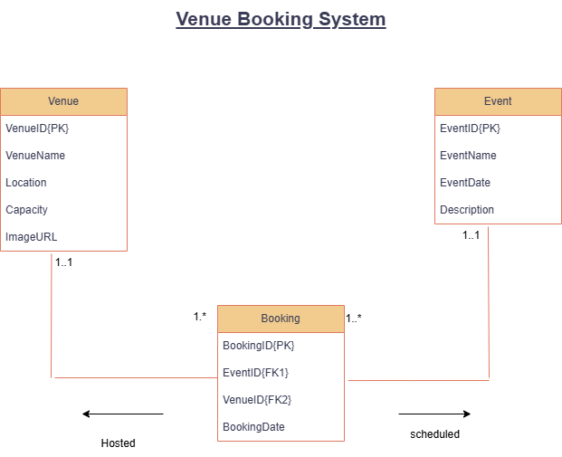

- Screenshot of Database created on Azure
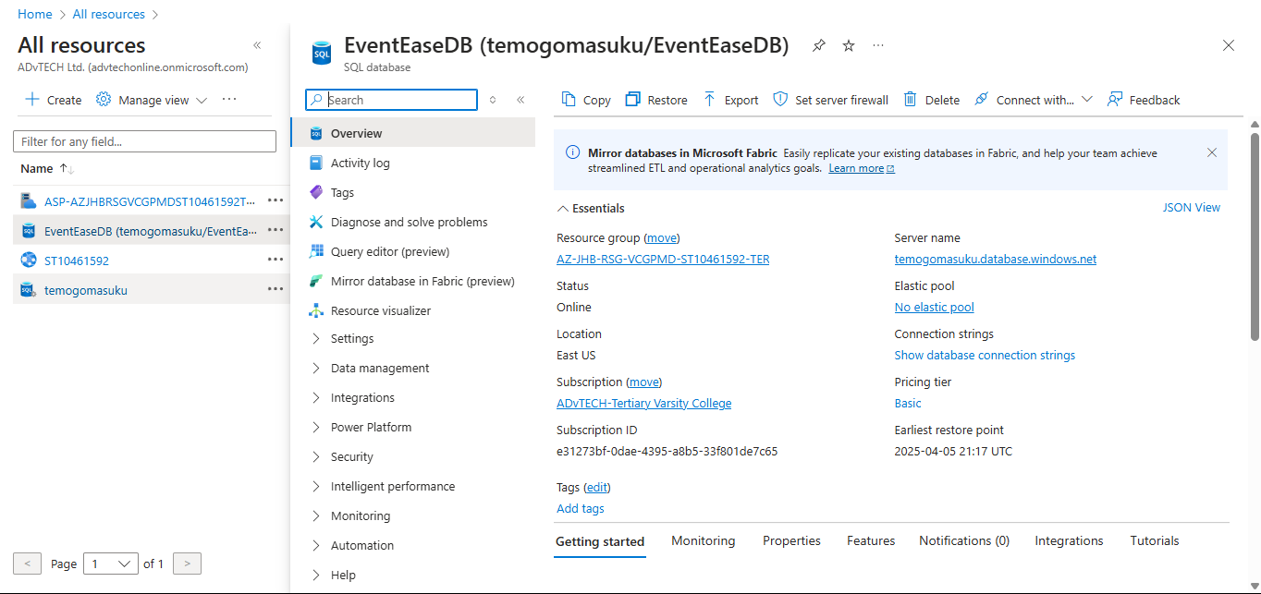

- Screenshot of migrated data and tables existing in query editor
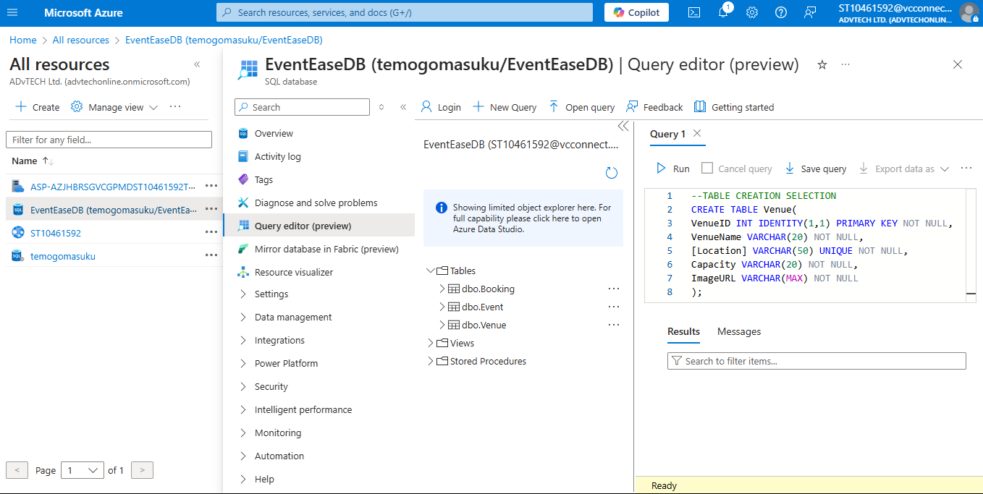

- Screenshot of successful deployment message in visual studio
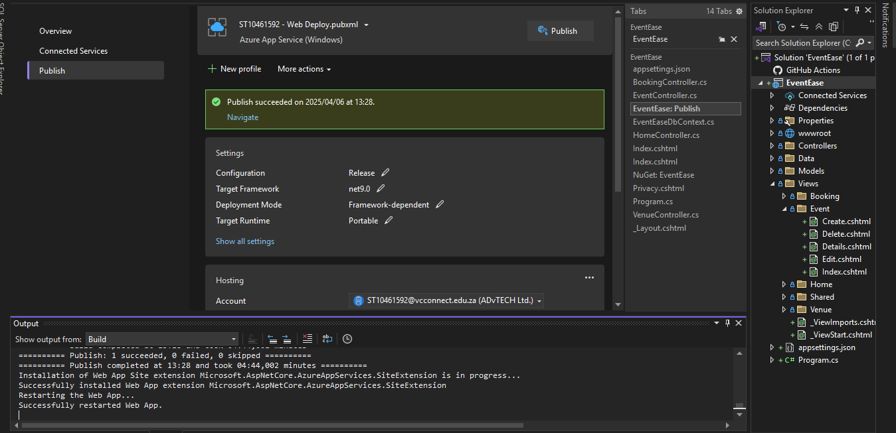

- D. On-premise and in cloud software are two different concepts that handle data in their own different ways. Deploying an application on-premise is different from deploying it in cloud with regards to security, deployment speed, and resource management. Cloud has an advantage when it comes to security because it’s harder to get access to information because it’s stored online. But that does not mean information is fully safe because there has been a number of cases where companies have been hacked and had their data stolen.
When it comes to on-premise software, information is stored at an actual building that can be attacked, and information gets stolen. On-premise software offers a level of control because the company’s hardware is used to store information compared to cloud, where it uses a provider’s server and is accessed through a web browser.
On-premise software deploys data within the organization, meaning they are responsible for everything relating to the data, including maintenance. There are different ways that data is deployed in a cloud software, but ultimately the data is on the service provider and can be accessed at any given time.
On-premise software is time-consuming, which also means that it’s cost-effective. It’s cost-effective because the company is responsible for maintenance and management. Cloud software is cheaper because it uses a pay-as-you-go model. Cloud software does not pay for maintenance, only for resources.
An example of deploying an application is on Azure, where you can use and benefit from all the features it has without worrying about maintaining the hardware.
- There are three different types of cloud-based computing services: SaaS (Software as a service), PaaS (Platform as a service), and IaaS (Infrastructure as a service). SaaS offers software over the internet, these tools can be downloaded and installed on users' devices. PaaS offers a platform for businesses and developers to be able to build and deploy applications.
IaaS offers a platform that users have to pay to be able to manage their data on the cloud. EventEase benefits from PaaS because developers have more control over the project and don’t have to follow someone else’s rules. PaaS allows developers to work together, meaning that the application can be easily managed, customized, and maintained. This also saves money. An example of this is developers working on a project on Microsoft Azure; it is easy to set up and understand, and you don’t need to spend money.

Bibliography
Cleo, n.d. On Premise vs. Cloud: Key Differences, Benefits and Risks. [Online]
Available at: https://www.cleo.com/blog/knowledge-base-on-premise-vs-cloud#:~:text=Simply%20put%2C%20the%20difference%20between,web%20browser%20or%20other%20interface.
[Accessed 5 April 2025].
Krysińska, J., 2024. On-premise vs. cloud computing: definition and differences. [Online]
Available at: https://nordlayer.com/blog/on-premise-vs-cloud-differences/
[Accessed 5 April 2025].
Paddle, n.d. SaaS vs PaaS vs IaaS: What's the difference?. [Online]
Available at: https://www.paddle.com/resources/saas-vs-paas-vs-iaas
[Accessed 5 April 2025].
SentinelOne, 2024. Cloud vs On-premise Security: 6 Critical Differences. [Online]
Available at: https://www.sentinelone.com/cybersecurity-101/cloud-security/cloud-vs-on-premise-security/#:~:text=The%20most%20crucial%20distinction%20between,and%20use%20remote%20data%20centers.
[Accessed 5 April 2025].

